**TASK -1 :- SMART LED**

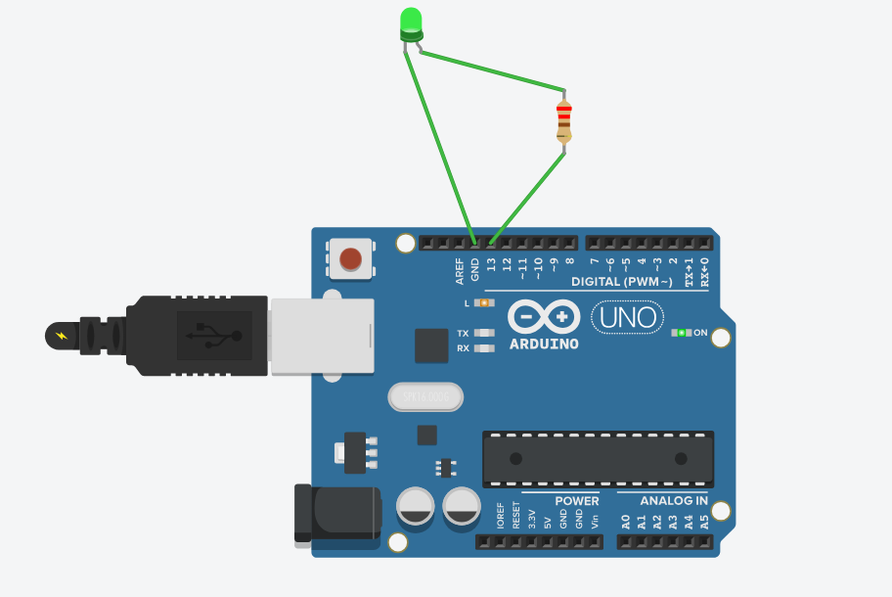

**Code:-**

int ledPin = 13;

void setup() {

pinMode(ledPin, OUTPUT);

}

void loop() {

digitalWrite(ledPin, HIGH); // Turn ON LED

delay(1000); // Wait 1 second

digitalWrite(ledPin, LOW); // Turn OFF LED

delay(1000); // Wait 1 second

}